InPlay SJPL Ingestion

April 2020

# Process

1. Input: The RSS feed URL (The URL is provided).
2. Process: Program will generate the output based from the input
3. Output: Excel file with UTF-8 texts

The output of the application will be located at **Desktop/InPlay SJPL Ingestion Output**

# User Interface

The RSS feed url

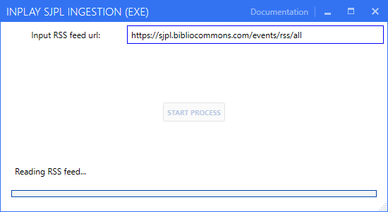

The status will be displayed here

Click the button to start the process

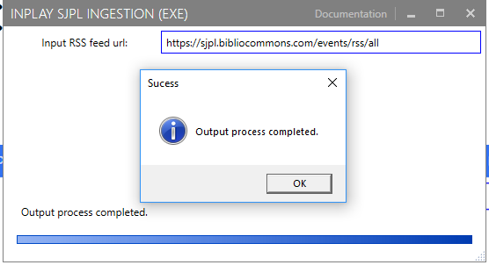

This window will display if the process is completed